IMD CA2 Stephanie Marsella

Contents
IMD CA2 Stephanie Marsella 1
Contents 1
Layout & Design 2
Nav bar 2
About Me 3
Experience 3
Contact 4
Code Used 4
Index.html 4
References 5

Layout & Design

Nav bar
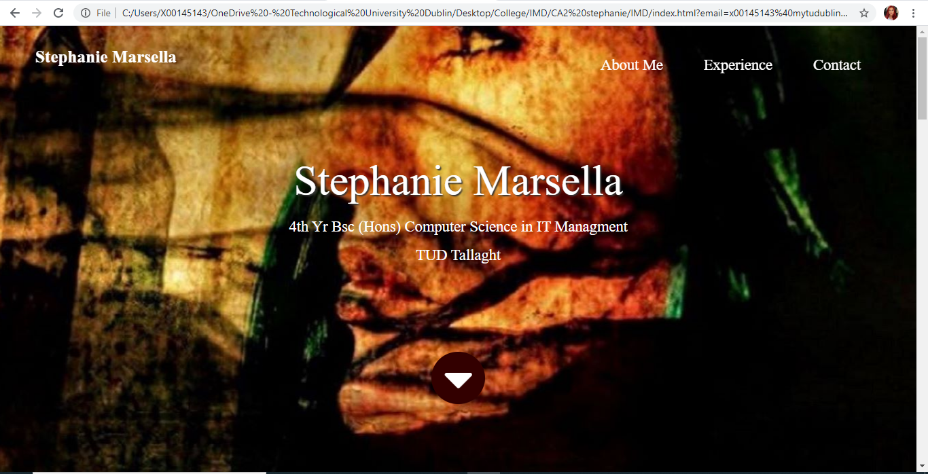
The website I created is one long page with a navigation bar at the top and the top and last section contains background image of me in parallax style that I used w3schools for help on creating.

- On my nav bar, I have my name in white for it to be easily visible, which brings you back to the top section of my website.
- I added an About Me that will bring you to that second section of the site and same with the Experience and Contact link which will also bring you to those sections of the site.
- This background parallax image of me has white text in the centre of my name, my email, and my profession/college studies.
- I added a button to scroll down to the next section just for style.

About Me
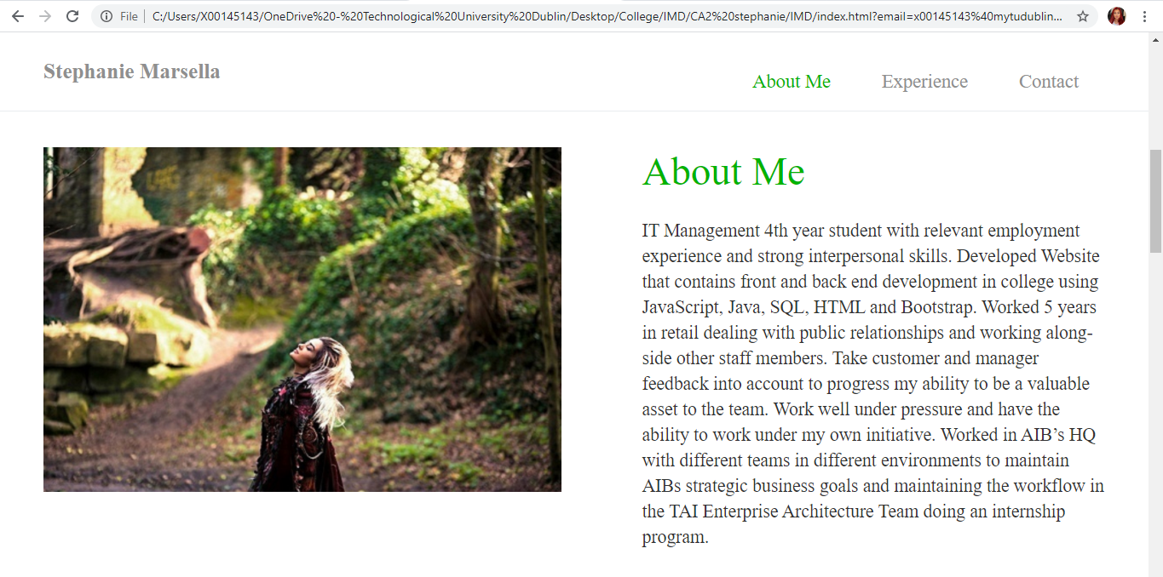
This is accessed by the scroll button on the top section, or the “About Me” on my nav bar or just by scrolling down on the right-hand side.
- This section of my website displays an image of me on the right and on the left is a paragraph of a brief introduction on me.
- You may scroll down or click on “Experience” on the nav bar to go to the next section.

Experience
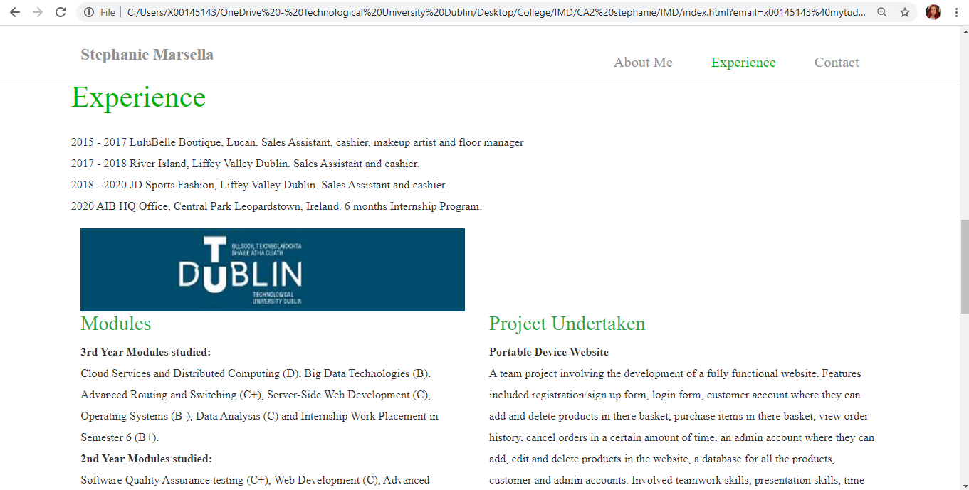
For my experience section it contains the information about my previous work including my internship. It contains my experience with modules I have done in college with my grades and it also contains my 2nd year project details on what I had to do, what tools I used and what challenges I faced.

Contact
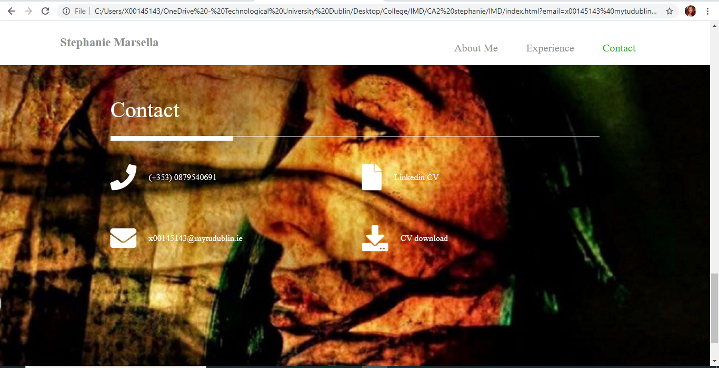
This is located at the bottom of the page and is the last section. This also contains a background image with a parallax style.
- I’ve added a link to my number with a phone icon
- A link to my Linkedin account containing my full CV to view
- A link to my outlook email in case someone wants to contact me on a job role
- A download link of my full CV
- I added a copy right text on my footer

Code Used

Index.html
This is the main document containing the layout of the design of my website. I added comments within my HTML and CSS files of what does which. I first linked my stylesheets, then I created a section called “hero” and 2 classes which is the top of my site which I will link too in my CSS files.
My nav section I created a container that links to the top section named “Stephanie Marsella”, to the introduction section “About Me”, the work section called “Experience” and the contact section.
For my hero section, I added a container to sit at the centre of the top section to include the following title “Stephanie Marsella”, a subtitle with my personal email, and my studies “Computer Science”. With the aid of w3schools, I also added a down scroll button for style on my hero section which just scrolls down to the next section of the site which is the introduction section (About Me section). I created a class that links to my fontawsome/css/f.css file which I based off fountawsome.com for help on creating the icons (phone icon, envelope icon, download icon and file icon).

References
I added some comments within my code but here is the sites I used:

I mainly used w3schools for my website and for the parallax idea https://www.w3schools.com/howto/howto_css_parallax.asp
https://www.w3schools.com/howto/howto_css_smooth_scroll.asp

getboostrap.com for my css and containers
https://getbootstrap.com/docs/4.3/layout/overview/

Fontawesome for my icons
https://fontawesome.com/icons?d=gallery

